Project Design Phase
Solution Architecture

Date | 15 February 2025
Team ID | SWTID-2026-2511
Project Name | Implement Client Script & UI Policy (Incident)
Maximum Marks | 4 Marks
Team Size | 5
Team Leader | RITIKA L
Team Members | MONISHA A  SARANYA G  ROSHINI A V  YASHIKA K

Solution Architecture:
Solution architecture is a complex process – with many sub-processes – that bridges the gap between business problems and technology solutions. Its goals are to:
- Find the best tech solution to solve existing business problems.
- Describe the structure, characteristics, behavior, and other aspects of the software to project stakeholders.
- Define features, development phases, and solution requirements.
- Provide specifications according to which the solution is defined, managed, and delivered.

Solution Architecture Diagram:

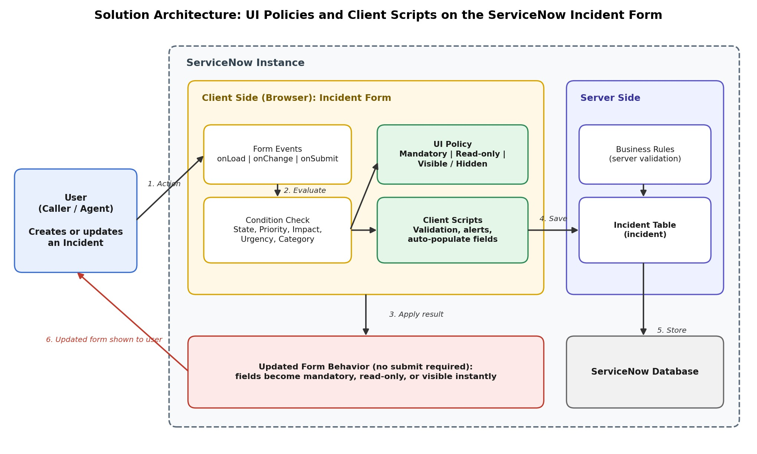
Figure 1: Architecture and data flow of UI Policies and Client Scripts on the ServiceNow Incident form
Data flow:
1. The user opens, creates or updates an Incident record in the ServiceNow form.
2. Form events (onLoad, onChange, onSubmit) trigger evaluation of conditions such as State, Priority, Impact, Urgency and Category.
3. UI Policies make fields mandatory, read-only or visible/hidden, and Client Scripts handle validation, alert messages and auto-population, all in the browser without a form submit.
4. When the user saves, the record is sent to the server, where Business Rules can apply further validation.
5. The validated record is stored in the Incident table of the ServiceNow database.
6. The updated form behavior is shown to the user immediately.

